Before you install, de-install the old app from the Windows Programs and Features window [ search for it, if necessary].

DOWNLOAD WARNING SCREENS:
Windows has upgraded it's security warnings. It will try to disallow my downloads now. This has become a complicated issue. Here is how to take care of it now:
This is an example of a blocked download:
.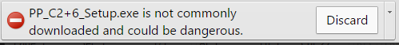
It looks like you can not download. What’s up?

Well, you can ignore this warning because you know this download is good –meaning no viruses.
So where do you go next?
Look closely at the Download-Discharge page.
On the right side. there is a little down arrow to the right of the Discard button.
Click on the arrow. A windom pops up. Click on the KEEP option:

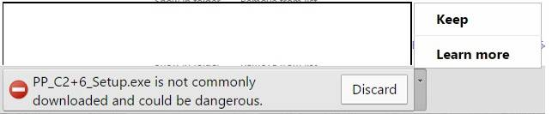

You are returned to the download icon and can download without restriction

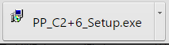

INSTALL BLOCK:
Sometimes Windows security will block installation:
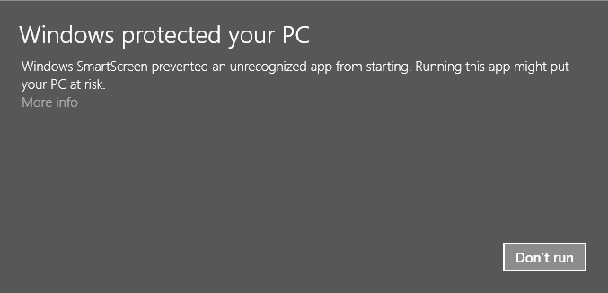
Look closely at the More info.. text. Click on it:
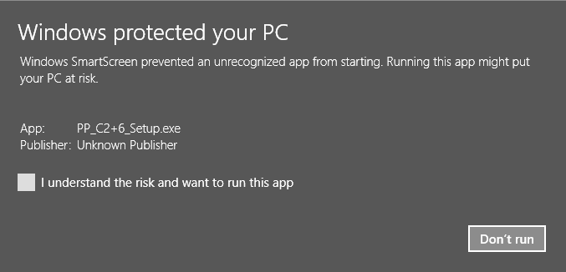
Check ‘I understand ..’ 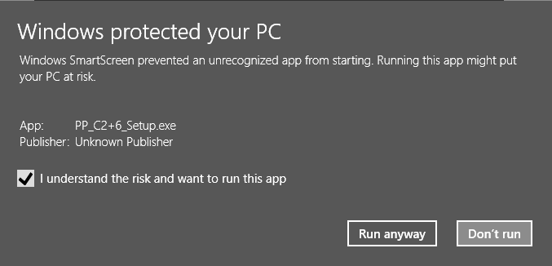
A new entry is added, so you can Run [Install] anyway.

That’s it.

Comments:
- These are large downloads. If you get any install errors, you must start over.
- This example was done on Google’s chrome browser. Other browsers have similar warnings.

